“GET YOUR MOJO ON”

Winter Fishing Tips
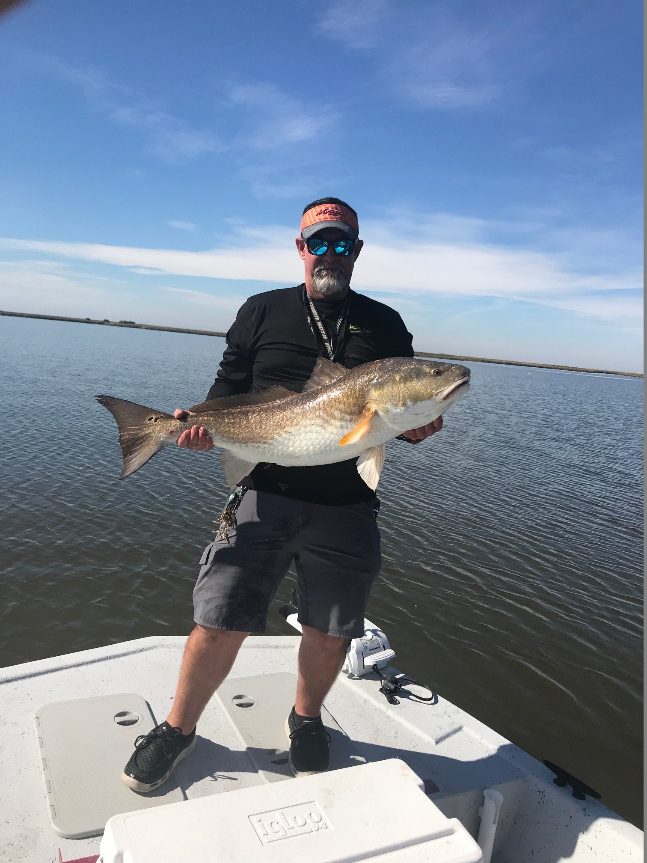 | Captain Steve Fleming is a USCG licensed & insured Charter Boat Capatian and professional tournament angler fishing out of Game-On Charters Lodge located in Dularge, Lousiana, minutes south of Houma. Captain Steve specializes in sight casting to redfish with artifical lures.  You can look him up on face book at Game-On Charters, or visit his web site.  www.game-oncharters.com

When cold fronts begin blowing in from the north, and water temperatures begin to drop below 70°, many anglers will find themselves struggling to consistantly catch fish. In addition to the cooler water temperatures, we will also experience lower tides as strong north winds blow water out of the marsh in South Louisia.

Last month Captain Steve Fleming wrote about Fall Fishing Tactics to help anglers with targeting redfish during the fall months. This month, Captain Steve will share two important winter fishing tips that will help anglers consistantly bag their limits during the cold winter months.

Many anglers will head straight for deep bayous and well sites when the weather dips down below the 40’s, and often the deeper water can be productive. What you need to understand is that the optimum water temperature for redfish is between 70° - 90°, and the critical low water temperature range is around 50° - 52°. For water temperature to reach a chilly 50° - 52° in South Louisiana, we will require a strong Canadian cold front that puts our ambient temperatures below freezing for several days, which doesn’t happen too often. In south Louisiana, we are often bundled up with layers of warm clothing in the early morning when we leave the dock, and begin peeling off layers of clothing by mid-morning.

Fishing Shallow Water Flats
Most species of fish, including redfish, are cold blooded, meaning they cannot regulate their body temperature. Therefore, they will move to deep water, or shallow water, to help maintain their body temperature. A slight noticeable change in water temperature by just a degree or two can make a huge difference in your success during the winter. As the sun begins to rise, shallow water will begin to warm up much faster than deeper water (especially shallow flats with a soft mud bottom). As the shallow water begins to warm, bait fish will begin to move into the shallow water, and the predator fish won’t be far behind the baitfish.

I prefer to find a ledge, or a drop off, and depending on the tide, wind and water clarity, I will fish along that ledge either on a shallow mud flat, or just a few yards into the deeper water. I will typically find redfish coming out of the deeper water onto the shallow mud flats in search of easy prey. This is a great winter fishing technique, especially in South Louisiana where we will get a strong blast of cold air that will hang around for a couple of days, and then begin to warm up with the southernly winds off the gulf. Bayous that are deep, and equally wide, with lots of shallow shoreline alongside of them are a perfect area to target during the cold winter months. I will usually target areas with 1’ – 3’ of water with soft mud bottom that is adjacent to 3’ – 5’ of water.

Slow your Roll & Down Size
One of the most common mistakes I witness on my boat during the cold winter months is many anglers fishing their baits far too fast. Have you ever stopped retrieving your bait to clear a backlash from your real, or to help your fishing partner for a moment, and begin retrieving your bait moments later and find that you have a fish online? I have experienced this many times, and the reason is due to the fact that as the water temperature drops into the 60°’s, redfish like most other species will become lethargic and exert less energy. Try downsizing the size and weight of your lure, and slowing your retrieve. I refer to this as “Slow your Roll”! Downsizing the size and weight of your bait will allow you to retrieve your lure much slower without getting hung up. Your lure needs to mimic a true baitfish in the same environment as the species of fish you are targeting.

Until next time, “Get Your Mojo On” and Tight Lines
Captain Steve Fleming
Mojo Pro Staff

www.Game-Oncharters.com

