“GET YOUR MOJO ON”
FISHING “POWER POINTS”
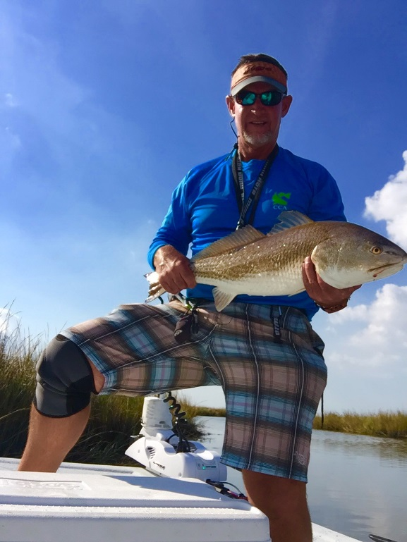 | Captain Steve Fleming is a USCG licensed & insured Charter Boat Capatian and professional tournament angler fishing out of Game-On Charters Lodge located in Dularge, Lousiana, minutes south of Houma. Captain Steve specializes in sight casting to redfish with artifical lures.  You can look him up on face book at Game-On Charters, or visit his web site.  www.game-oncharters.com

In last month’s article, Captain Steve encouraged anglers to stop fishing spots, and to start reading the water. He will follow up this month with tips that will help anglers with reading the water and identifying “Power Points” to increase your chances of bagging your limit every time out.
We will start with defining “Power Points”, and then discuss several of the most common power points that can be found in any body of water with tidal movement and current. Understanding Power Points and being able to identify them will help anglers increase their chances of success.
Power Points – As stated in our previous article, most game fish are predators that stage in areas that provide opportunities for an easy meal. We refer to these areas as “Power Points”. The following tips will help anglers easily identify power points, and provide tips on how to fish them successfully.
Structure - Anglers should focus on structure in the water (pilings, busted up piers, logs, sunken boats, etc.) because structure provides excellent cover for game fish, allowing them to ambush their prey. When fishing structure, you will want to cast down alongside of the structure, and work your bait down the side of it, or on top it. If this isn’t possible, cast over the structure retrieving your bait across it. Fish will typically be staged on the down current side of the structure. When fishing structure, I prefer to throw a spinner bait, such as Redfish Magic by Strike King Lure Company. The depth of water fished can easily be controlled with a spinner bait by raising & lowering your rod tip and varying your retrieve. Jig heads with a soft plastic will also work well in these areas, but it is more difficult to control the depth, increasing your chances of hanging up. Any lure has the potential of hanging up when fishing structure. However, fishing structure and following these tips will also increase your chances of hooking up!
Eddy Currents - An “Eddy Current” is a circular current of water. The swirling motion of eddies in the water cause nutrients and bait that are normally found in deeper water to come to surface. Eddy Currents can be split into two different categories; Static Eddies, and Transient Eddies. The most common found in the shallow inland bays and marsh are “Static Eddies”, which are caused by the flow of water (current) around an obstruction such as structure in the water, an abrupt change in water depth, a bridge piling, etc. Anything that will obstruct the direct flow of water causing the water to flow around it (splitting the flow of water), causing the water to wash back towards the obstruction once it has flowed over or around it. Eddies can occur in any depth of water, and create prime areas to target. In the inland bays and marsh, the most common eddies can be found at the mouths of bayous and small trenasses, or around a sharp bend in a bayou or bank with a strong moving current such as a rising or falling tide. These areas tend wash bait back towards the obstacle that disrupted the flow of water, creating a pocket where larger predator fish lay and wait for an easy meal. When fishing any eddy, you want to cast past the obstacle that is creating the swirling motion, and work your bait into the back wash of the eddy. Eddies are probably one of the most overlooked areas that will produce fish, and one of my favorite areas to target. Pay attention to the water when fishing a strong falling/rising tide and focus on these areas. You will be surprised with the amount of fish that a small eddy will hold. The larger the area of the eddy, the greater number of fish it can potentially hold. These areas are best fished with lead head jigs with your favorite soft plastic, and spinner baits.
Grass Beds and Flats – Predators, such as redfish and trout, can easily be found on flats, small ponds, and large lakes that hold an abundance of grass. Many people don’t like fishing thick grass areas because they can be difficult to run without over heating your outboard (because the grass can potentially clog your water intake). Fishing thick grass also requires anglers to change their fishing technique which can potentially take them out of their element. When fishing heavy grass, you typically need a high tide that will provide 3 – 6 inches of water covering the grass. On low tides, the grass will usually float on top of the water making it almost impossible to fish with any kind of lure. When fishing grassy ponds in the marsh and inland bays, target them on high tides, look for bait, and fish your power points. Recommend lures are weedless spoons, spinner baits, and even top waters if there is enough water cover. Weedless spoons and spinner baits are my preference because they can be retrieved consistently, keeping them just above the grass. An angler can easily control the depth of these baits by raising or lowering their rod tip, along with adjusting the speed of their retrieve. You will want to keep your bait just above the grass as you retrieve it. Slow your retrieve until you start snagging the top of the grass, then speed it up slightly to ensure your bait is free of grass and achieves maximum action. Focus on flats, ponds, and larger shallow lakes with a high tide that have plenty of grass.
Pot Holes – “Pot Holes” are typically found in areas with a large amount of grass, as well as areas with mud bottoms. The most common are shallow flats and shallow ponds and lakes with an abundant of grass. “Pot Holes”, similar in description to the pot hole in the parking lot of your favorite boat ramp, will be areas within the grassed over flats and ponds, and don’t hold grass, creating a small, grass-free pocket. Like I stated in the above power point, when fishing pot holes in a grassy area, an angler will want to focus on these areas with a high tide. Predator fish such as redfish and large trout, will hang out in, or near pot holes preying on helpless bait as they wonder into the area. When fishing pot holes, pay special attention to bait activity in and around the pot holes. Cast your lure past the pot hole, and retrieve it slowly towards the target. Once you are over it, try pausing your retrieve or lowering your rod tip, allowing your lure to fall slowly into the center of the pot hole, and then slowly lift your rod tip and begin your retrieve. If there is a fish in or around the area, you are certain to hook up. I prefer to fish these areas with a soft plastic rigged on a weedless hook, or spinner baits.
Drop-Offs – “Drop-Offs” are another area that is often overlooked by many anglers. Fishing the drop-offs within a river, bayou, or shoreline can produce large numbers of fish and increase any angler’s chances of success in bagging their limits. Any angler can focus on these areas with a high or low tide, middle of the summer, or in cold winter weather conditions. The other advantage to fishing drop-offs in a bayou or river, is that there is usually some water movement regardless of current/tidal movement. If possible, cast down the edge of the drop-off, retrieving your lure alongside of it. The fish may be holding in the deeper water along the drop-off, or on the shallow side of the drop-off. Work both the shallow side and the deep side of the drop-off until you locate the fish, and then concentrate in that water depth. These areas typically hold redfish and trout, as well as flounder. When fishing drop-offs, I prefer throwing spinner baits, and lead headed jigs with a soft plastic. The weight of the jig head will depend on the depth of water targeted, and current. Strong currents will require a much heavier lure.
Any angler who can identify these power points, will certainly increase their chances of catching fish. You may need to move around from one area to another, but be certain to give each area a chance to produce. Look for active bait, change up your technique by raising or lowering your rod tip and adjusting the speed of your retrieve. Be patient, fish it thoroughly, and ensure you focus on the power points mentioned above. Any angler who can put all these tips together is certain to turn a day of fishing, into a day of catching.
Until next time, “Get Your Mojo On” and Tight Lines!

Captain Steve Fleming
Mojo Pro Staff

