“GET YOUR MOJO ON”
“REDFISH”
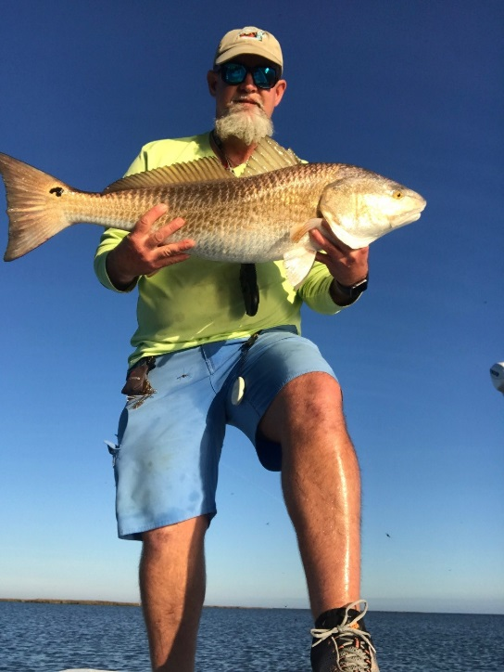 | As a charter boat captain who specializes in targeting redfish, I am frequently asked questions about the species and their habitats by anglers of all ages and experience levels. Because of these frequently asked questions, we will devote this article towards explaining some facts about the species. Much of the information contained in this article is founded and supported by studies conducted by Tag Louisiana, a non-profit organization that depends on volunteer anglers to catch, tag, and release redfish throughout Louisiana, and the Gulf Coast.  PROPER NAME: Red Drum  FISH FAMILY: Sciaenidae (Drum and Croakers)  OTHER NAMES: Redfish, Red, Spottail, Channel Bass, Poisson Rouge
DESCRITION: Redfish can be silvery-gray with a copper cast or bright copper colored with an iridescent gray cast. Color depends largely on the water the fish comes from; the belly is typically white. Fish that are harvested in deeper water tend to be silvery-gray in color, while fish that are harvested in shallow waters tend to appear a bright copper color. Most fish will have a single ocellated spot located just ahead of the tail fin. Occasionally, more than one spot can be found, and rarely, not any spots are present. There are rumors that redfish with multiple spots are farm raised fish which have been released into the wild, while those with just a single spot are wild hatched. I personally have not been able to find any data which supports these theories one way or the other.

Redfish are aggressive and opportunistic feeders and the result is evident in their growth rate. At age 1 they average over 13 inches and by age 2, they average over 21 inches long. Blue crabs make up a large part of their diet, but the species will also feed on finfish and shrimp. Although redfish are known to come to the surface to take top-water artificial baits, they are typically bottom feeders. Commonly eaten fish include sea robins, lizardfish, menhaden, mullet, pigfish, Atlantic croakers, and flounder. Most of these are bottom-living species.

SPAWNING: Redfish, like many other members of the drum family, spawn in high salinity waters in areas of high tidal current flow, such as near barrier islands and passes. Spawning usually takes place over an 8 or 9-week period from mid-August to mid-October. During this period, male redfish stake out in large numbers in the prime spawning areas, in and near the passes, being ready to spawn virtually every night. There they form large schools at night, called drumming aggregations, because of the drumming sound that they make with their air bladders to attract females. Females, on the other hand, tend to appear at these areas only when immediately ready to spawn, which seems to be once every 2 to 4 days. This means that most redfish taken during this time by recreational fishermen are males, rather than females. While the 2-month spawning period is less than half that for spotted seatrout, the spawning potential of an individual redfish is truly stupendous. At an average of 1-2 million eggs per spawn, and a spawning every 2 to 4 days, the average female can be expected to produce 20-40 million eggs per season.

While it has been a generally accepted rule of thumb that redfish leave inshore waters when they mature at around age 5, there is a lot of variation in this. Immature 2 to 5-year old fish have been found in the offshore schools. Also, a small percentage of females mature at age 3 and about 9 pounds in weight. A few males mature even sooner, at age 2 and around 5 pounds. All females are mature by age 6 and all males by age 5. Once mature, redfish typically will spawn for the rest of their lives. The term “Bull Red” refers to your larger redfish, typically over 30” in length, and are actually females.

HABITAT: Redfish are found Gulf-wide, from low-salinity or even freshwater estuaries out to offshore waters up to 50 feet deep. Redfish are not fussy about bottom type, being found on everything from soft mud to hard bottoms of shell hash and oyster reefs. Often, large schools of large redfish will congregate at nearshore artificial reefs and oil and gas platforms in the northern Gulf, and the shallow water estuaries and inland bay systems.

SIZE DESCRIPTION: Redfish are very common from 1-10 pounds in estuaries and inland bays, although larger fish are not uncommon. Redfish caught in offshore waters are usually over 10 and often over 30 pounds.

FOOD VALUE: Some may argue, but in general, redfish are considered good table fare, with smaller fish being considered better table fare than larger fish.

Until next time, “Get Your Mojo On” and Tight Lines!

Captain Steve Fleming
Mojo Pro Staff

